**Supporting Information:**

**Photoresponsivity enhancement in monolayer MoS2 phototransistors by rapid O2:Ar plasma treatment**

Jakub Jadwiszczak1,2,3, Gen Li1,2,3, Darragh Keane2,3,4, Conor P. Cullen2,3,4, Jing Jing Wang2, Yangbo Zhou1,2,3,5, Daniel S Fox1,2,3, John J. Boland2,3,4, Georg S. Duesberg2,3,4

& Hongzhou Zhang1,2,3, *

*1School of Physics and CRANN, Trinity College Dublin, Dublin 2, Ireland*

*2Centre for Research on Adaptive Nanostructures and Nanodevices (CRANN), Trinity College Dublin, Dublin 2, Ireland*

*3Advanced Materials and BioEngineering Research Centre (AMBER), Trinity College Dublin, Dublin 2, Ireland*

*4School of Chemistry, Trinity College Dublin, Dublin 2, Ireland*

*5School of Material Science and Engineering, Nanchang University, Youxun W Rd, Xinjian Qu, Nanchang Shi, Jiangxi Sheng, China*

[*hozhang@tcd.ie](mailto:*hozhang@tcd.ie)

Mobility was evaluated using…

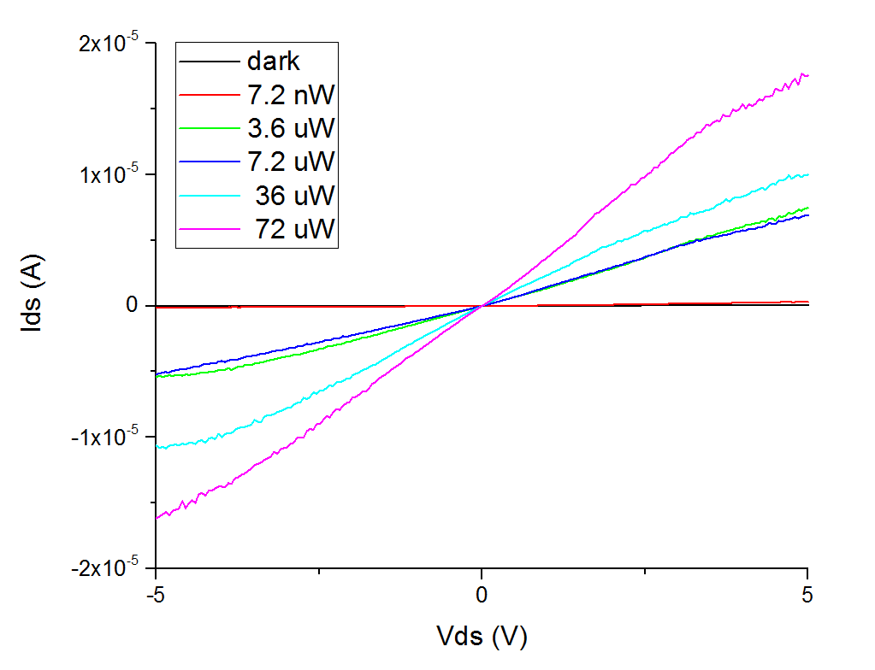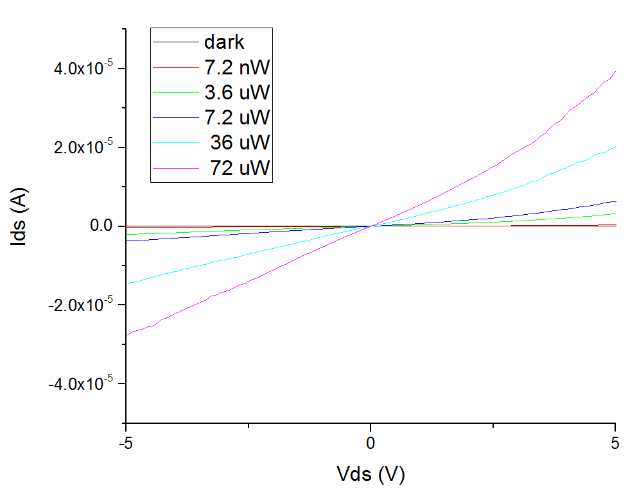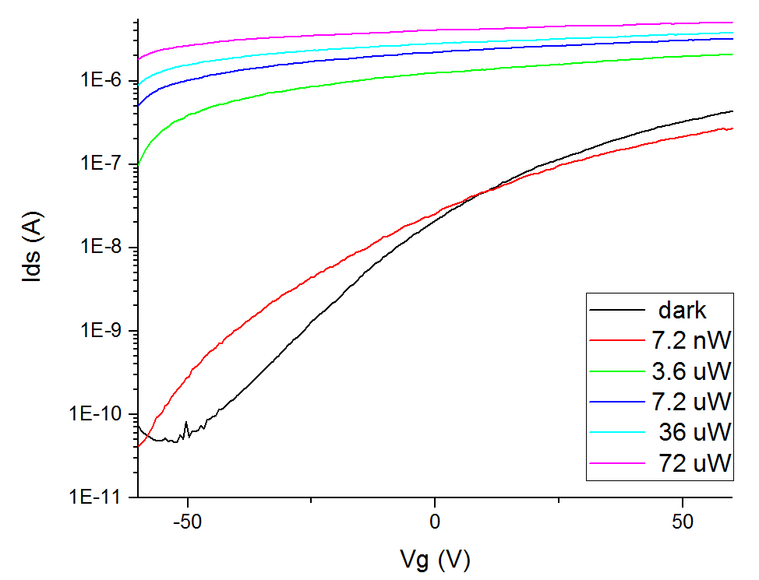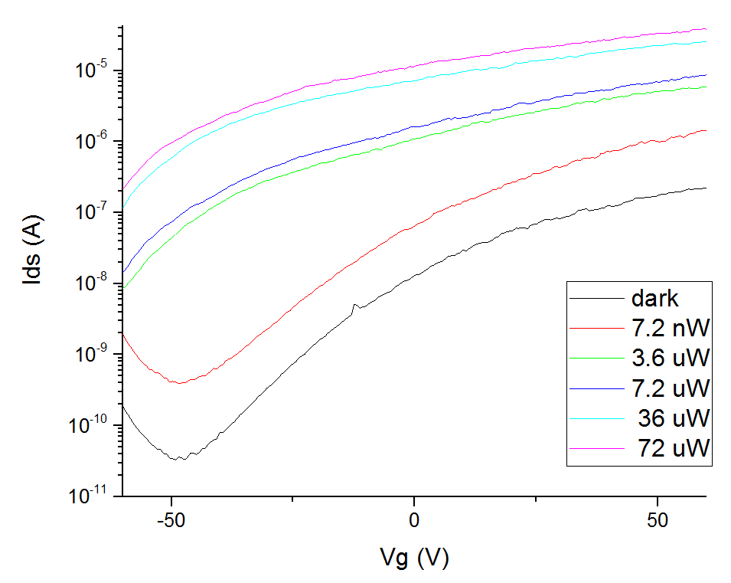

**Figure S1:**

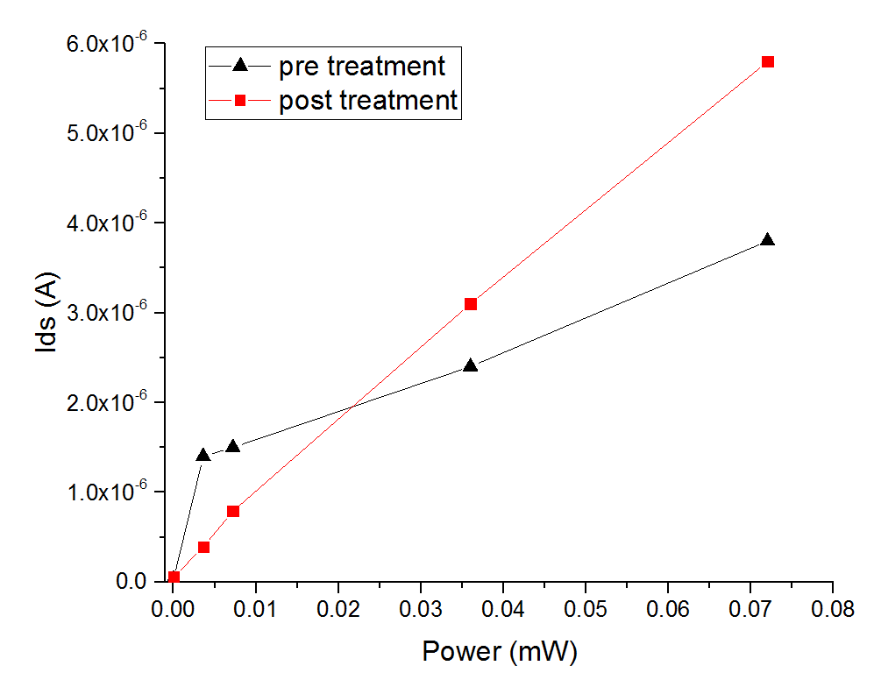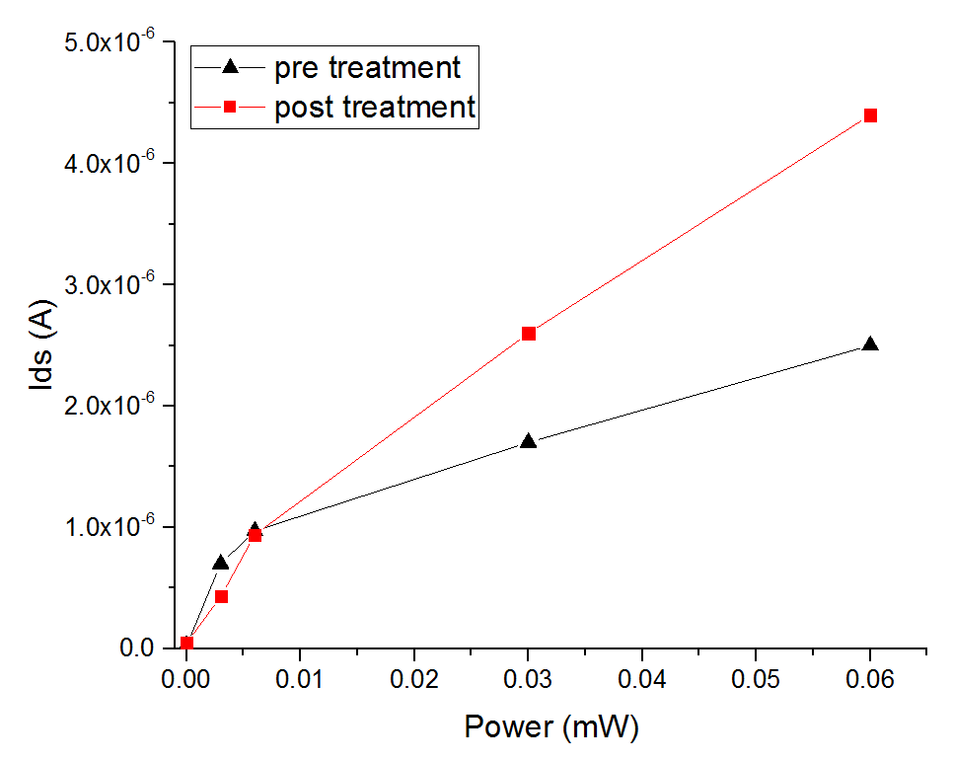

**Figure S2:**

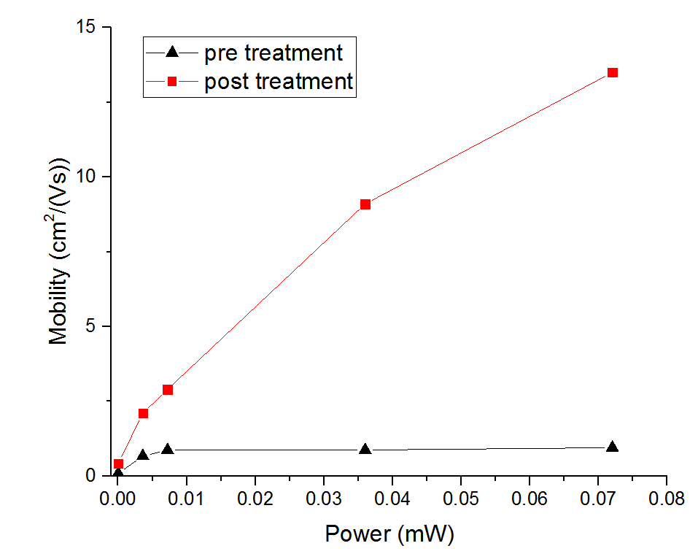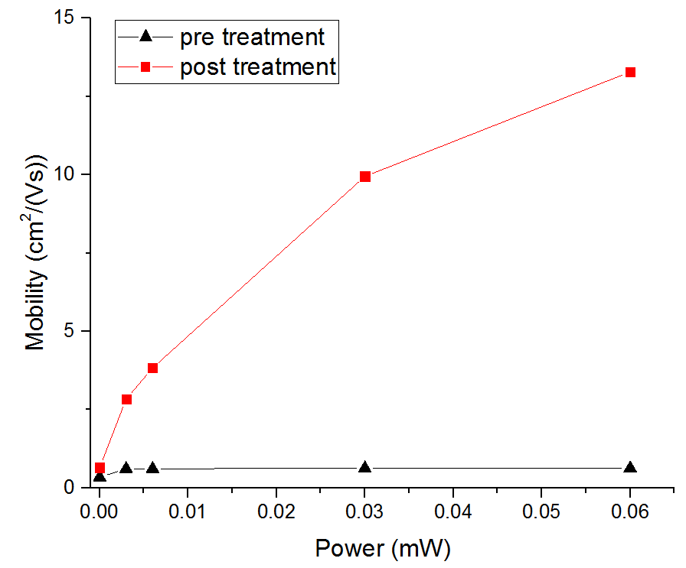

**Figure S3:**

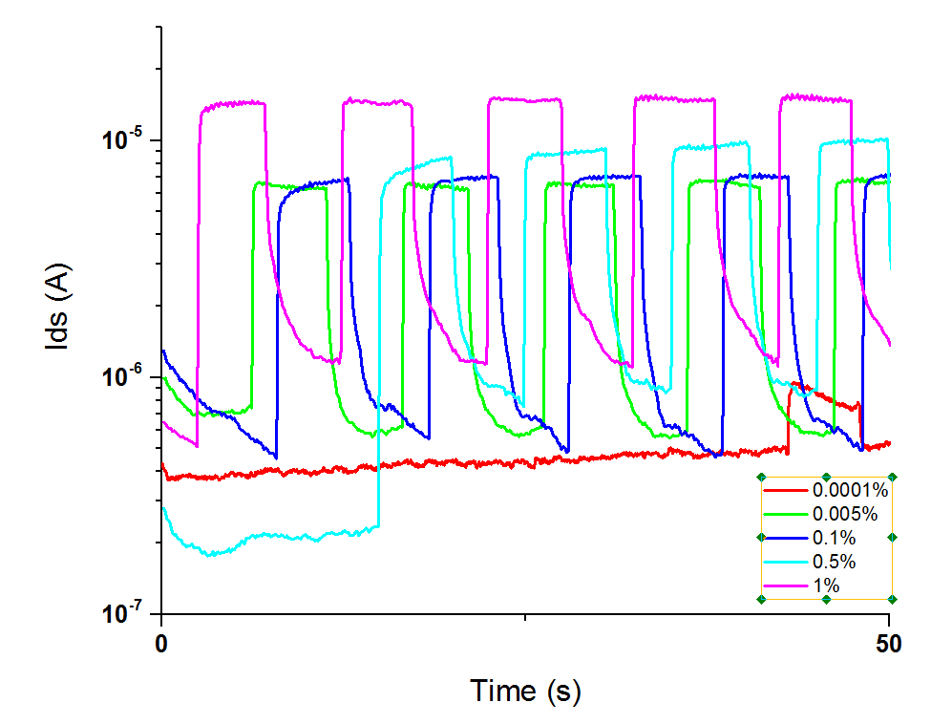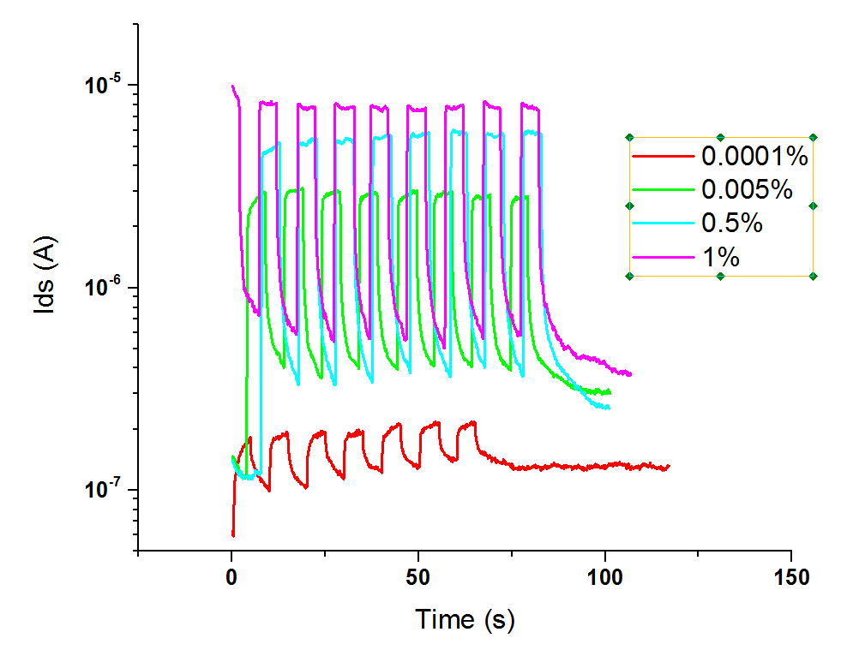

**Figure S4:**

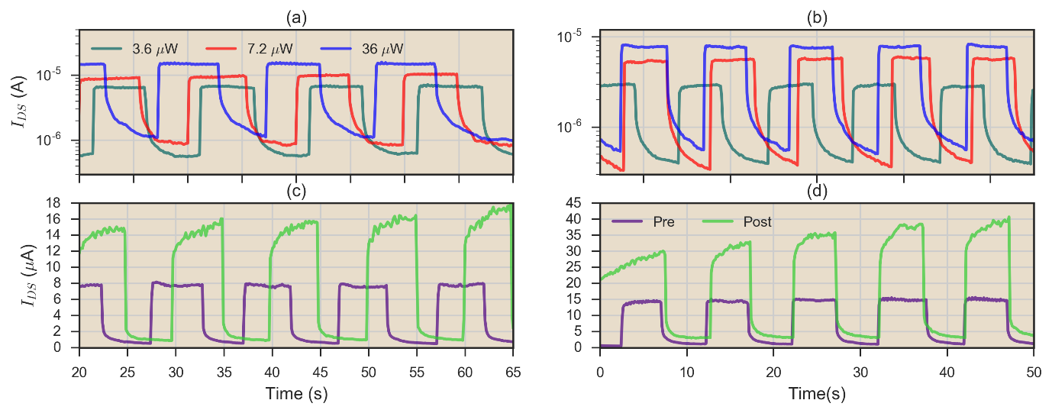

**Figure S5:**

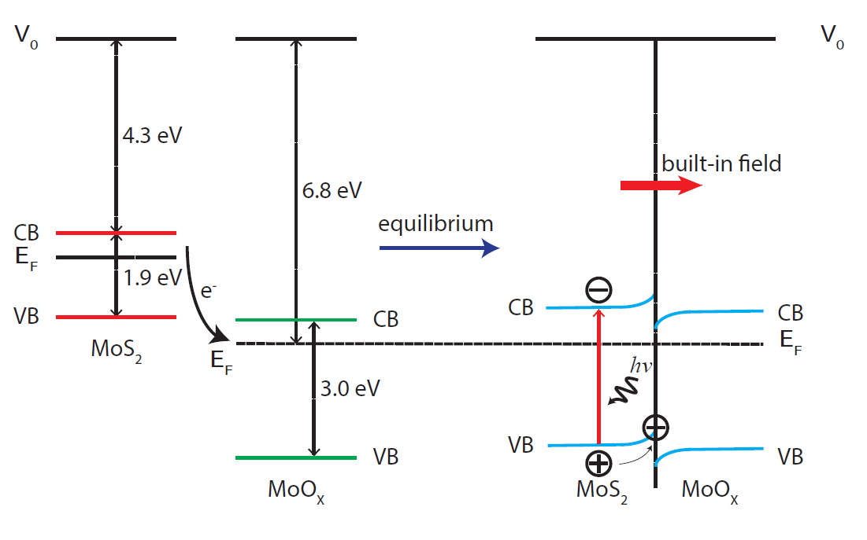

**Figure S6:**